Behavioral Simulation (Before Clock)

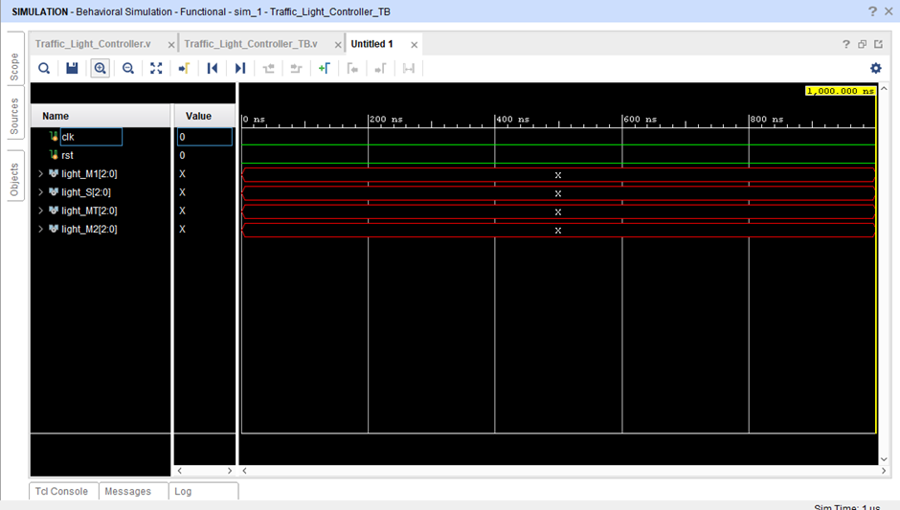

Behavioral Simulation (After Clock)

